MOBILE FSM

**FOR STARHUB FIELD SERVICE MANAGEMENT (FSM)**

|  |  |
| --- | --- |
| Prepared for:  StarHub Ltd    67 Ubi Ave 1 Starhub Green  Singapore 408942 | Prepared by:  Huawei International Pte Ltd    15A Changi Business Park Centre 1  Eightrium @ Changi Business Park #03-#03/04 Singapo­re 486035 |

|  |  |
| --- | --- |
| Document Version | 2.00 |
| Document Reference No |  |
| Document Date | 25 November 2015 |

**Revision Record(修订记录)**

|  |  |  |  |
| --- | --- | --- | --- |
| **Date** | **Revision Version** | **Change Description** | **Author** |
| 2015-11-25 | 1.00 | Initial Document. |  |
|  |  |  |  |
|  |  |  |  |
|  |  |  |  |
|  |  |  |  |
|  |  |  |  |
|  |  |  |  |
|  |  |  |  |
|  |  |  |  |
|  |  |  |  |
|  |  |  |  |

**References（参考）**

|  |  |  |  |
| --- | --- | --- | --- |
| **No** | **Document Name** | **Version** | **Author** |
| 1. |  |  |  |
|  |  |  |  |
|  |  |  |  |
|  |  |  |  |
|  |  |  |  |
|  |  |  |  |
|  |  |  |  |
|  |  |  |  |

**Document Approval / Acceptance**

|  |  |
| --- | --- |
| **Huawei International Pte Ltd** | |
| Signature:  Name  Designation :  Date : | Signature:  Name :  Designation :  Date : |

|  |  |
| --- | --- |
| **StarHub Ltd** | |
| Signature :  Name :  Designation :  Date : | Signature :  Name :  Designation :  Date : |
| Signature :  Name :  Designation :  Date : | Signature :  Name :  Designation :  Date : |

Table of Contents

1 LoginScreen 错误！未定义书签。

2 OffLine E-CAF 错误！未定义书签。

3 Sliding Menu 13

**3.1 List SA………………………………………………………………………………………………13**

**3.2 Notification………………………………………………………………………………………15**

**3.3 Check CPE………………………………………………………………………………………..17**

**3.4SoftwareVersion……………………………………………………………………………….21**

**3.4 Logout……………………………………………………………………………………………..22**

4 Service Activity Details 23

5 Install CPE 31

6 Collect CPE 37

7 Completion of CPE 42

3 Cutomer Survey 45

4 E-CAF Process 48

1. **Login screen:**

* MobileFSM login functionality is shown below screen shot.
* Login with credentials.

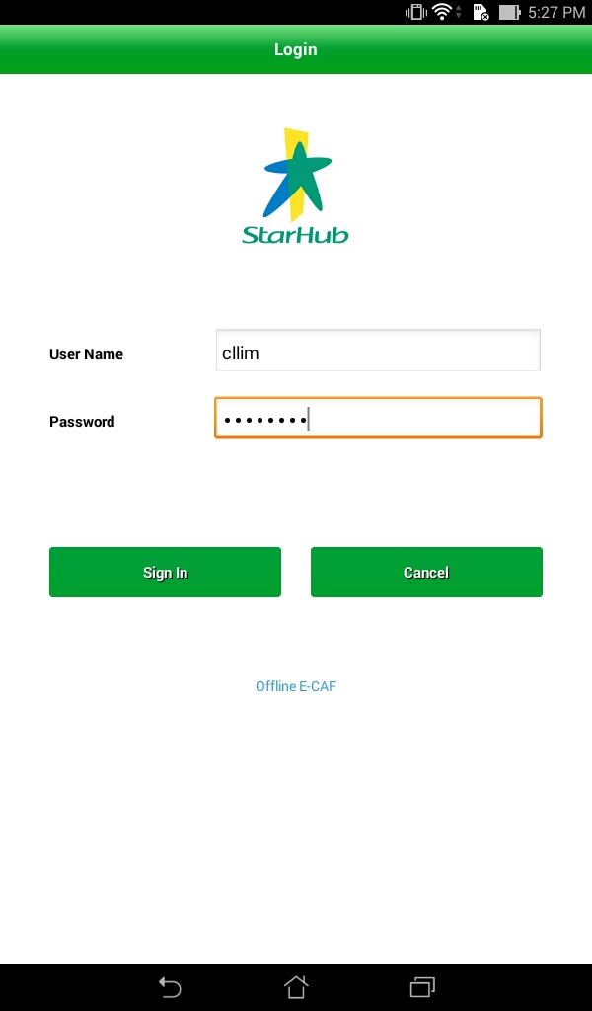

1. **Offline E-CAF:**

* We can take customer acceptance on offline.
* Click offline E-caf at login screen below screen will display.

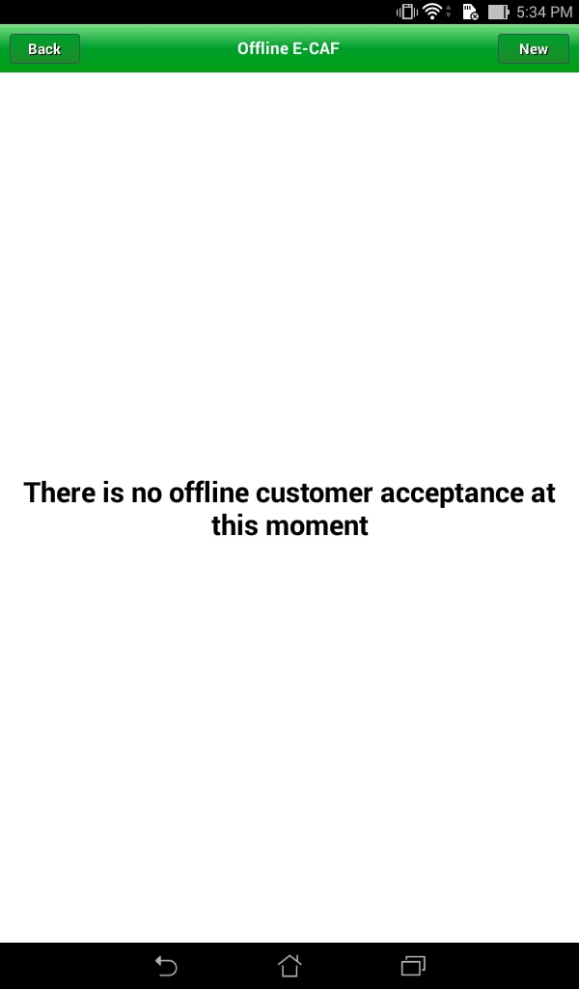

* From above screen, If we press the ‘New ’ button Empty Customer information form will display.
* In below screen we can enter the all parameters.

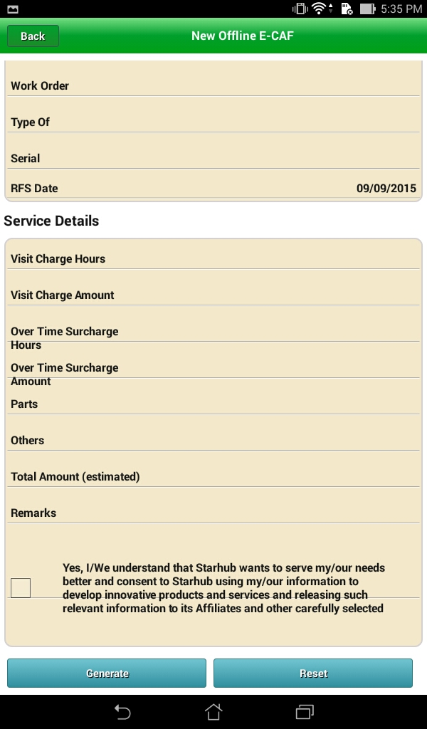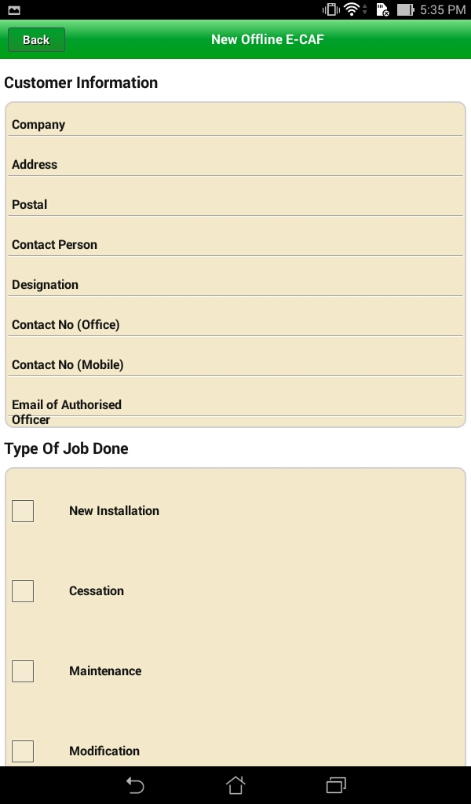

* After filling the all parameters press ‘Generate’ button.
* Then you can see below screen.

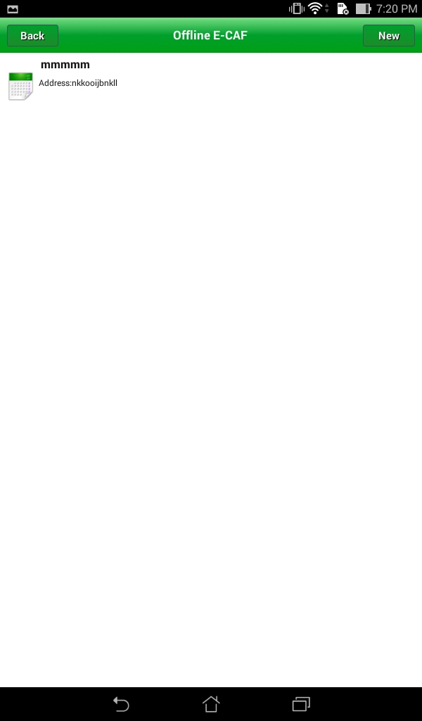

* Edit that customer information, press on icon.

It will display below page.

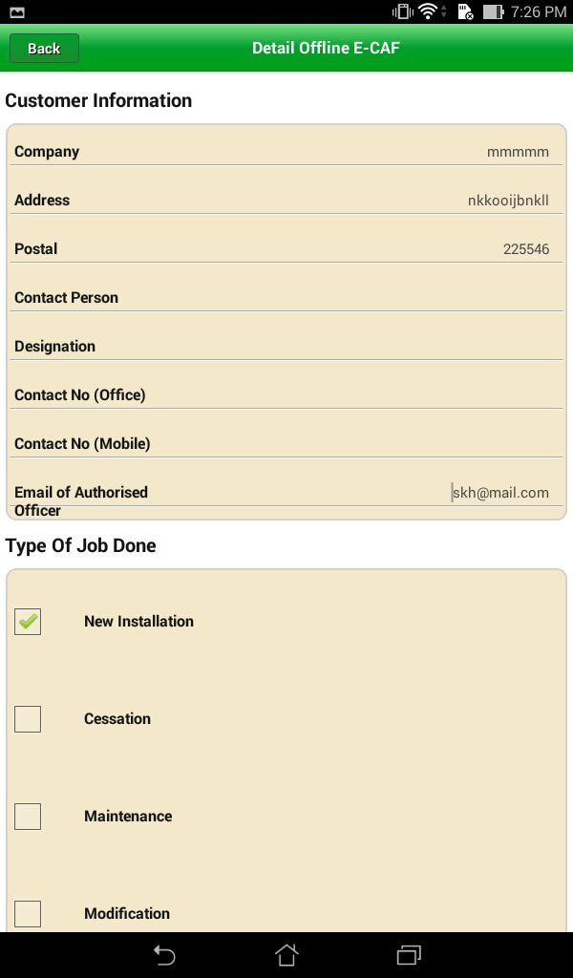

* After editing the form page press ‘Regenerate’ button. Then you can see the below screen

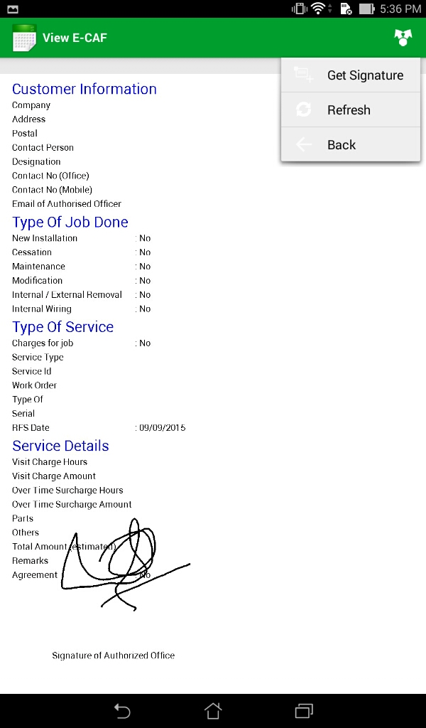

* From the above screen, we can take signature.

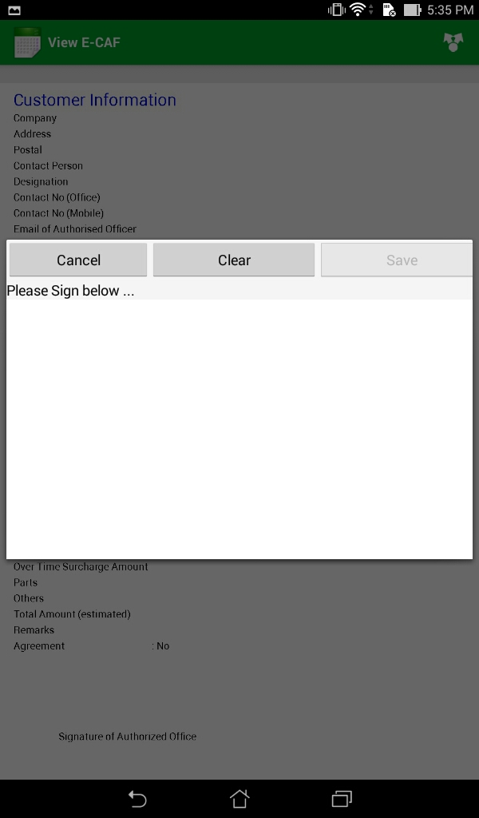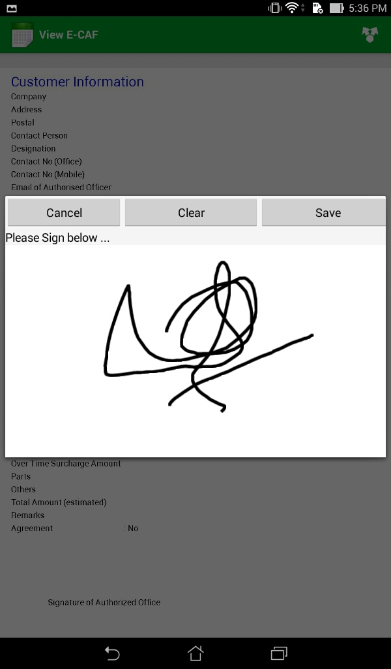

1. **Sliding Menu:**

**3.1 List SA:**

* For getting the sliding menu, we can drag left screen.

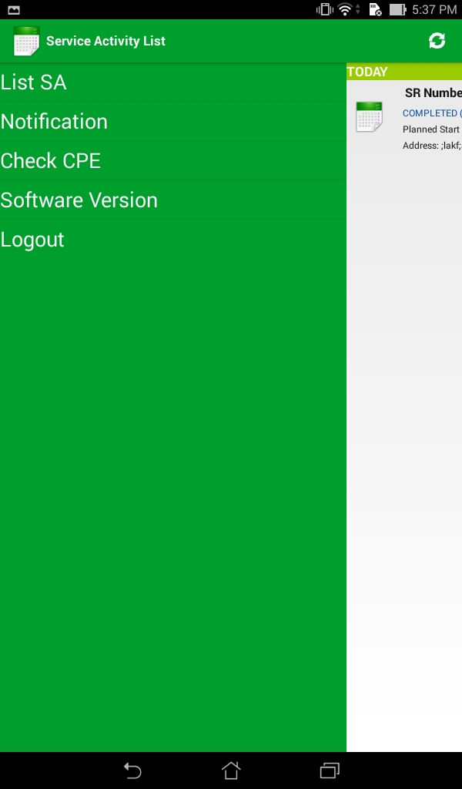

* If press ‘List SA’ , then list of SA will display. Find below screen.

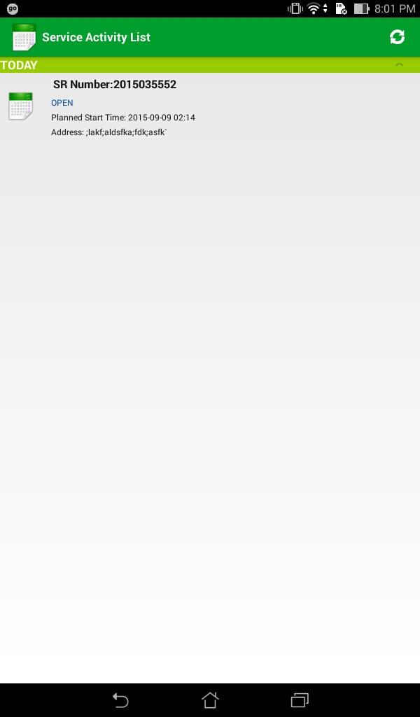

**3.2** **Notification:**

* If you press the ‘Notification’ button, it should display list of

Notification messages.

* Find the below screen.

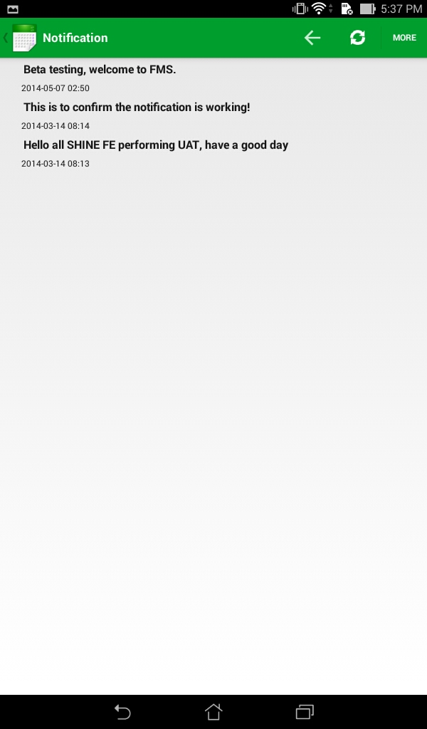

* In above screen, If you press the ‘More’ button the page will refresh.
* If you want read each message, click on messages.
* Find the below screen.

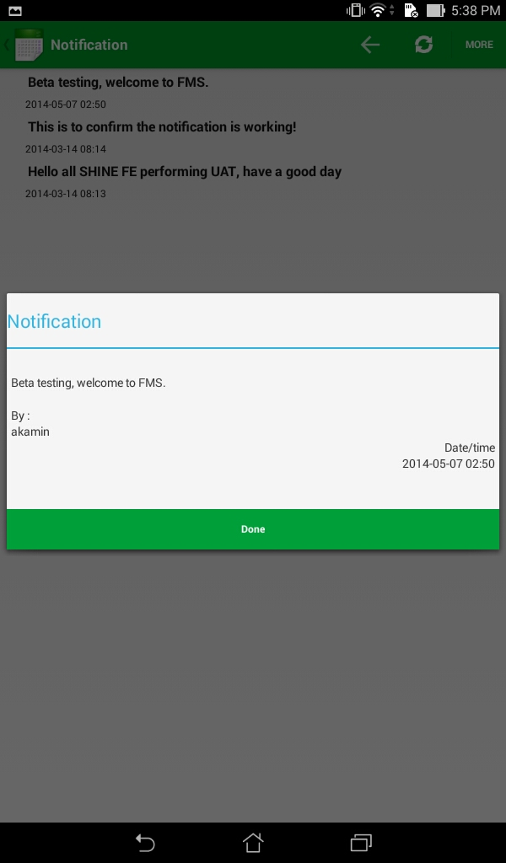

**3.3 Check CPE:**

* Press ‘Check CPE’ button, then below screen will display.

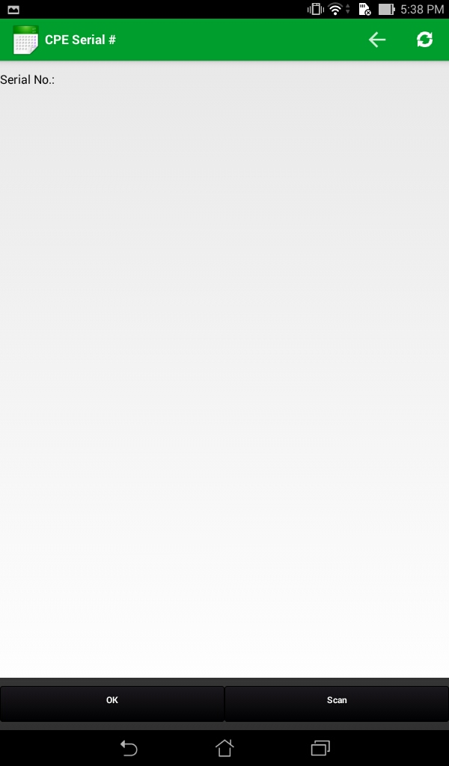

* Enter the CPE Serial number and click ‘Ok ’.
* Want to scan barcode press scan button. It will scan the CPE bar code (serial number).
* Find the below screen shot

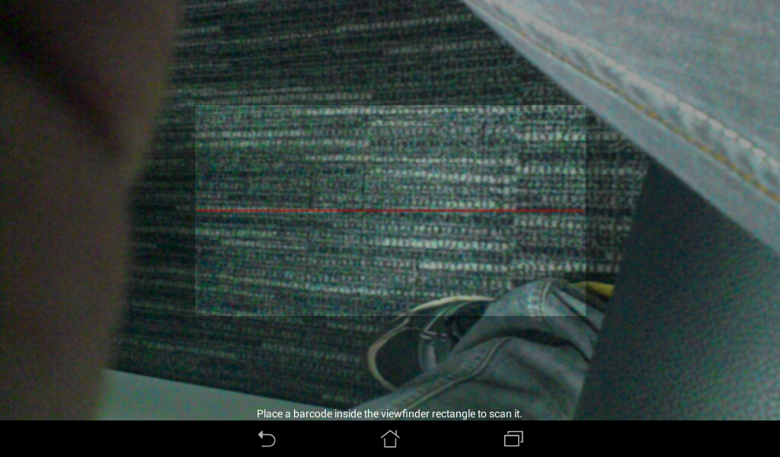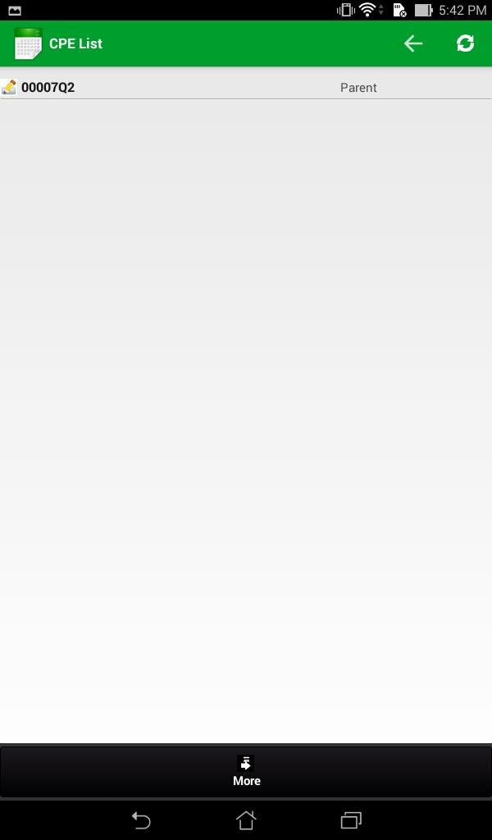

* Click on CPE for details.

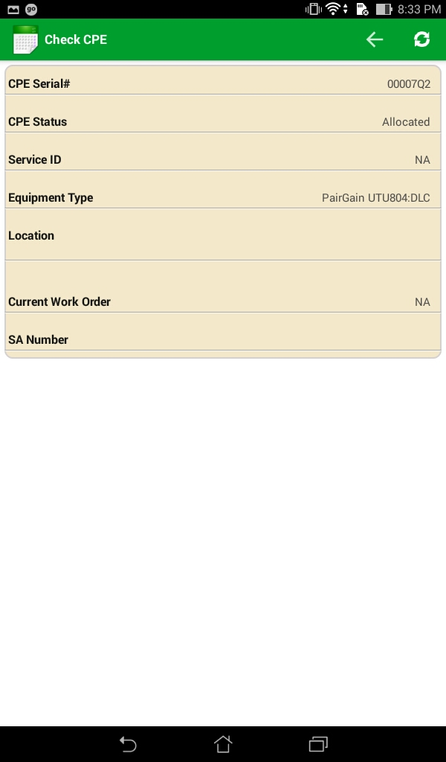

**3.4 Software Version:**

* Find version of the application.

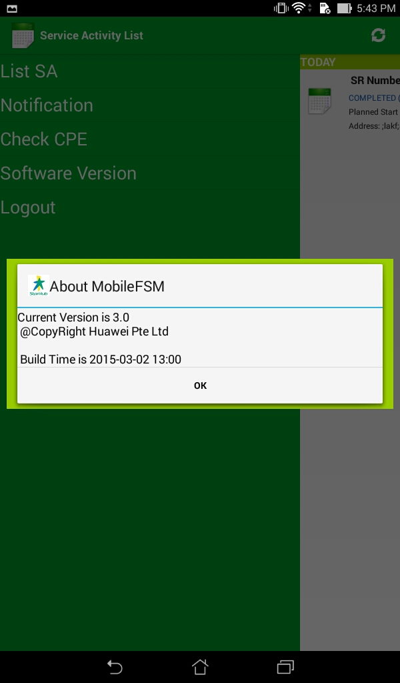

**3.5** **Logout**:

* Click on Logout button for exit the app.

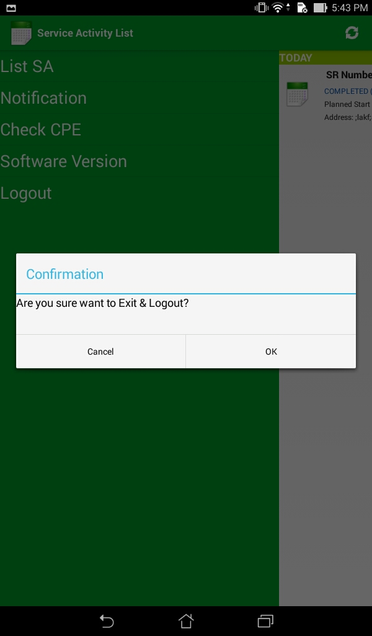

1. **Service Activity details:**

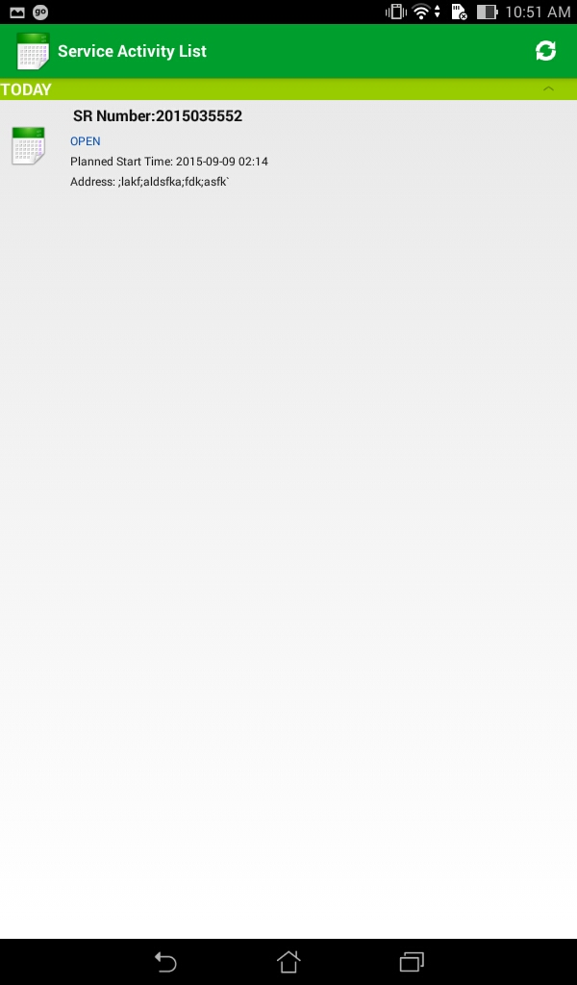

* If you click on service activity, the service activity details will appears.
* Please find the below screen shot.

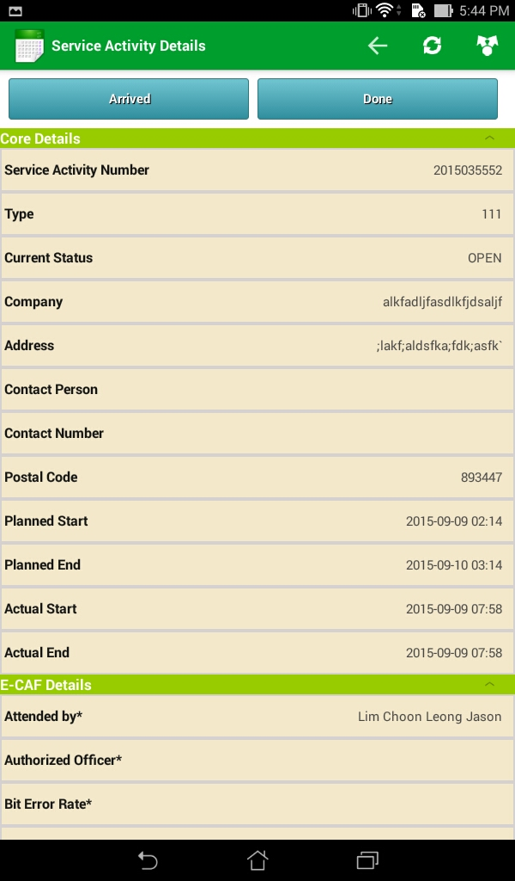

* We can edit the service activity details. Find the below screen shots

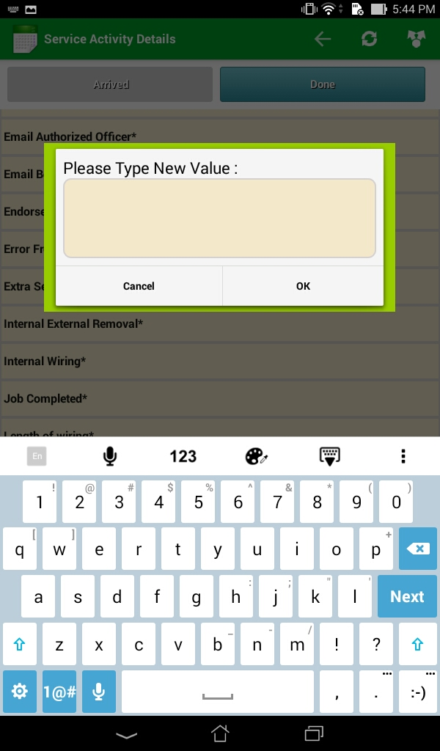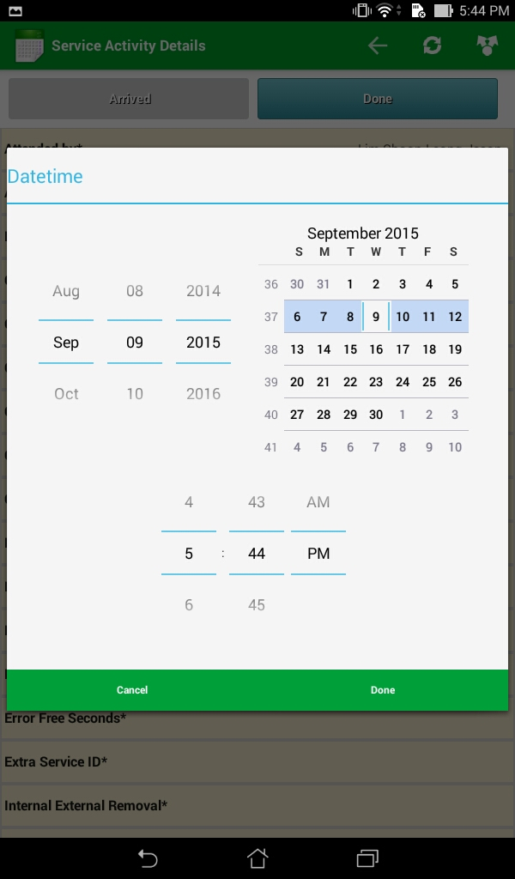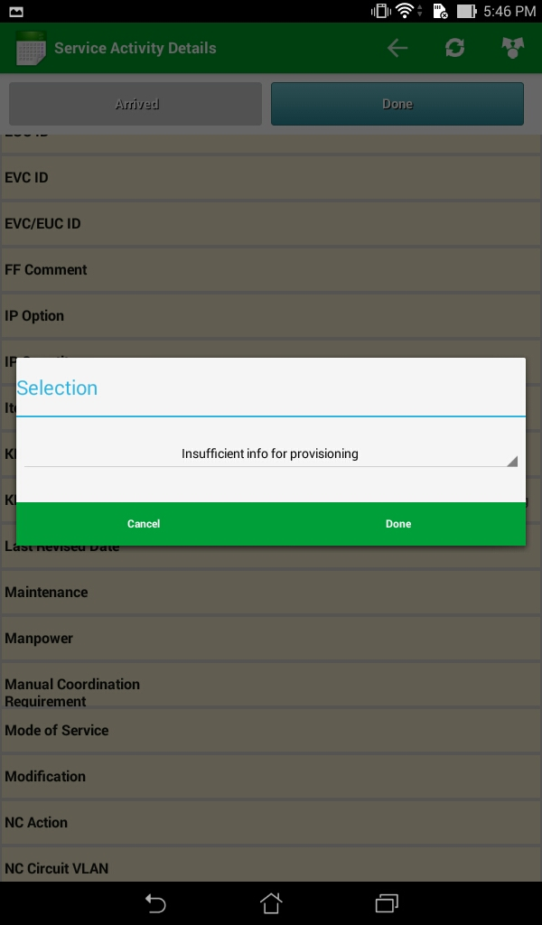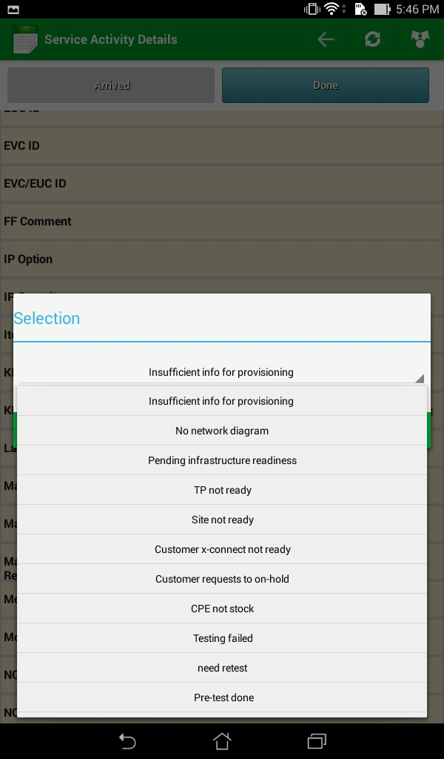

* Before starting the service, click on ‘Arrived’ button.
* Please find the below screen shot.

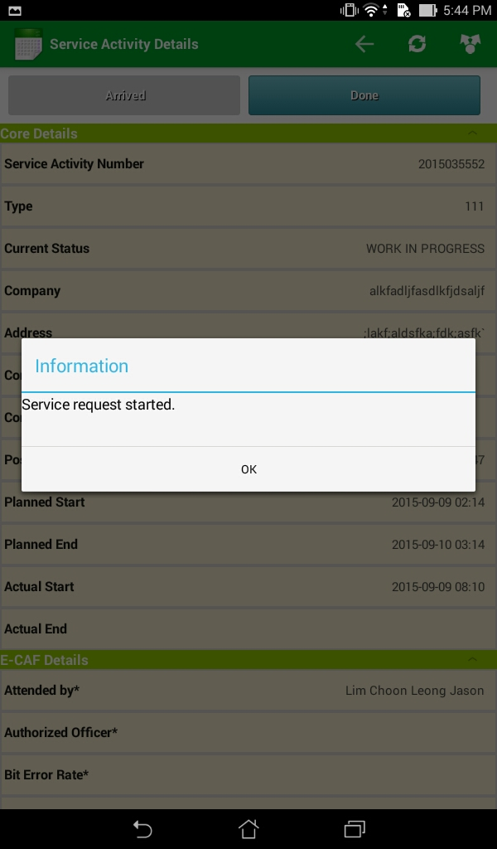

* The above dialogue box is showing that service is started.

1. **Install CPE :**

* Login FSM Android application
* Click Service Activity listed under the Service Activity List page.
* Click menu / navigation button on right top
* Click Install CPE

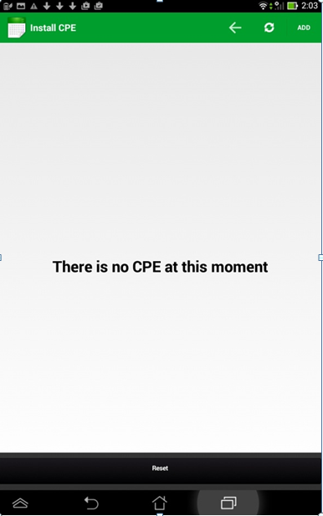

* **Click** ADD **button**

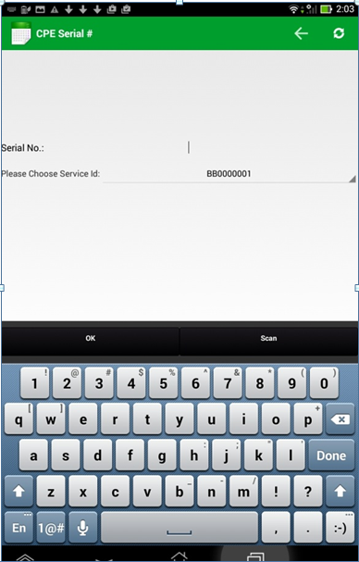

* Input or Scan Serial No.
* Click OK button

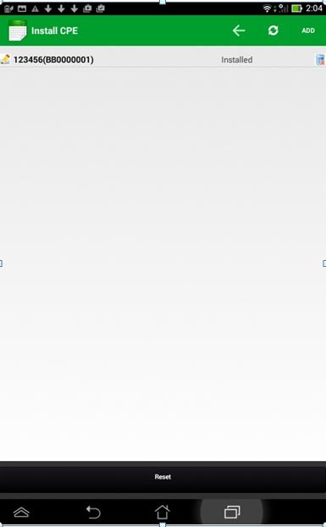

* Click on the CPE
* New page will appear. All attributes of the selected CPE & its children CPEs will be listed.

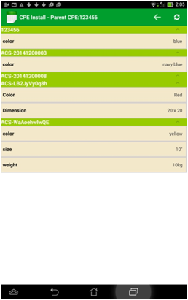

* Click on one attribute.
* Attribute editing window will appear

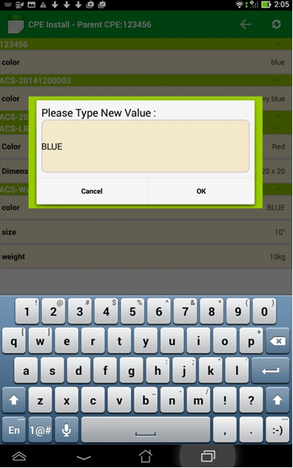

* Input new attribute value
* Click OK button, Attribute value will be updated.

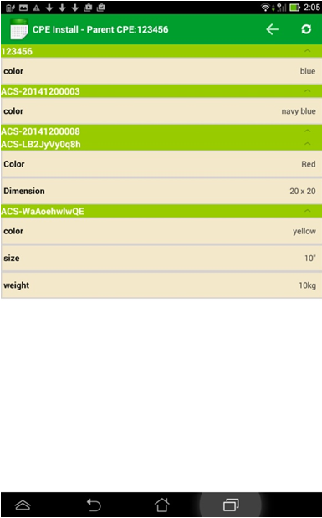

1. **Collect CPE :**

* Login FSM Android application
* Click Service Activity listed under the Service Activity List page.
* Click menu / navigation button on right top
* Click Collect CPE, Collect CPE page will appear.

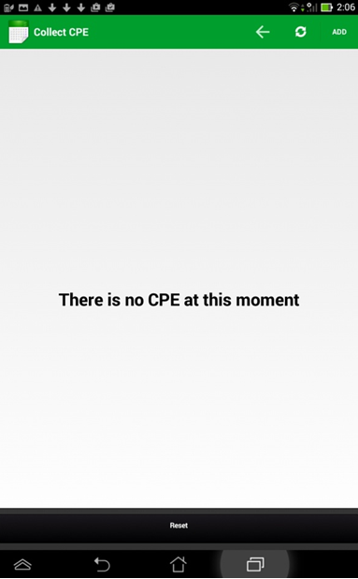

* Click ADD button, CPE Serial #pagewillappear**.**

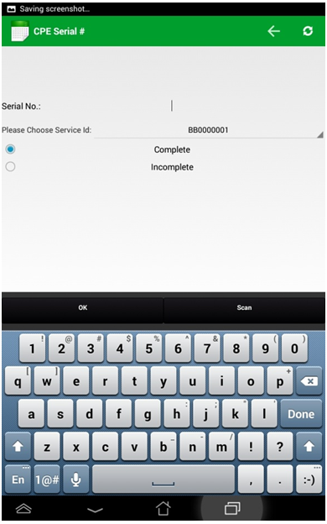

* Input or Scan Serial No.
* Tick Complete or Incomplete
* Click OK button, CPE with input serial number will be listed asCollected.

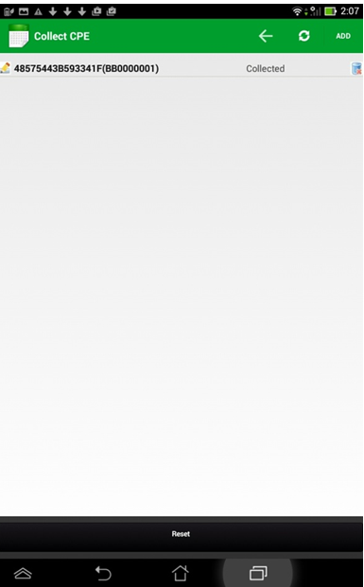

* Click on one CPE
* New page will appear all customer attributes of this CPE & its children CPEs will display**.**

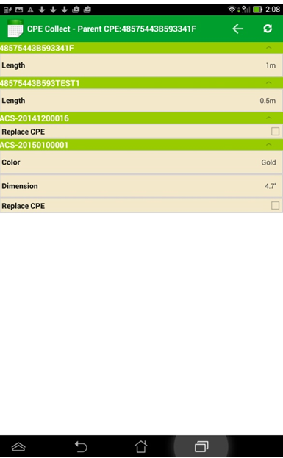

* Tick the REPLACE checkbox beside one or more accessories
* Navigate back to SA page
* Click Done
* Navigate back to Check CPE
* Input the collected parent CPE SN
* If there is spare accessory found in inventory, the old accessory child will be replaced. If there is no spare accessory found in inventory, processing won’t be block.

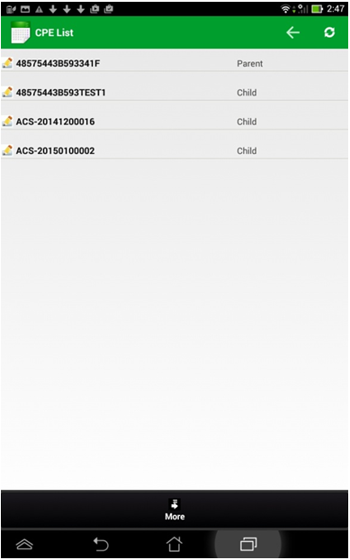

1. **Completion of SA :**

* Login FSM Android application
* ClickService Activitylisted under the Service Activity List page.
* ClickDone button.
* ChooseSuccessful **or** KIV-xx.
* ClickOK button. Donebutton will turn grey**.** Current Statuswill beupdated.

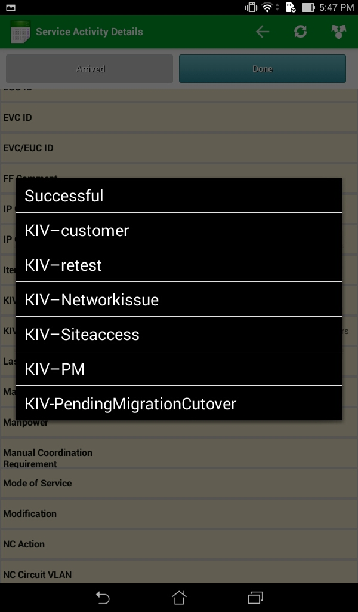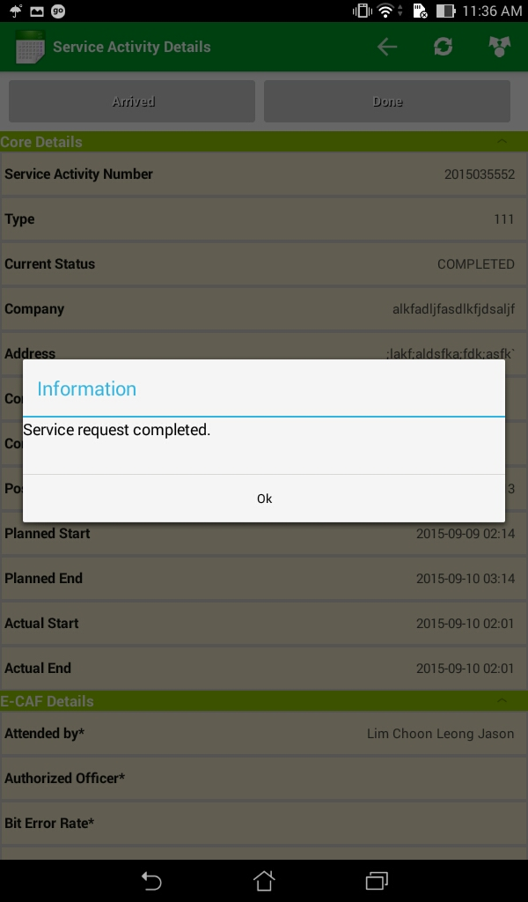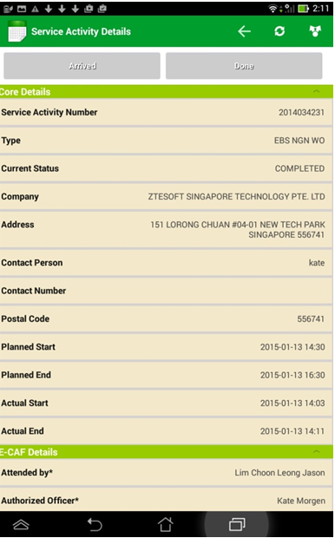

1. **Customer survey :**

* If the service activity is completed with ‘Successful’, below pop up will disappear.

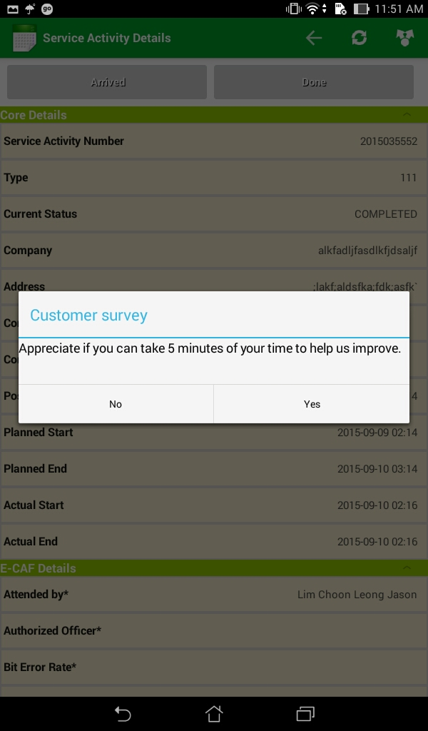

* If you don’t want to take customer survey press ‘No’ button, then E-CAF form will open.
* If you want to take customer survey click on ‘Yes’ button.
* Please find the below screen shot.

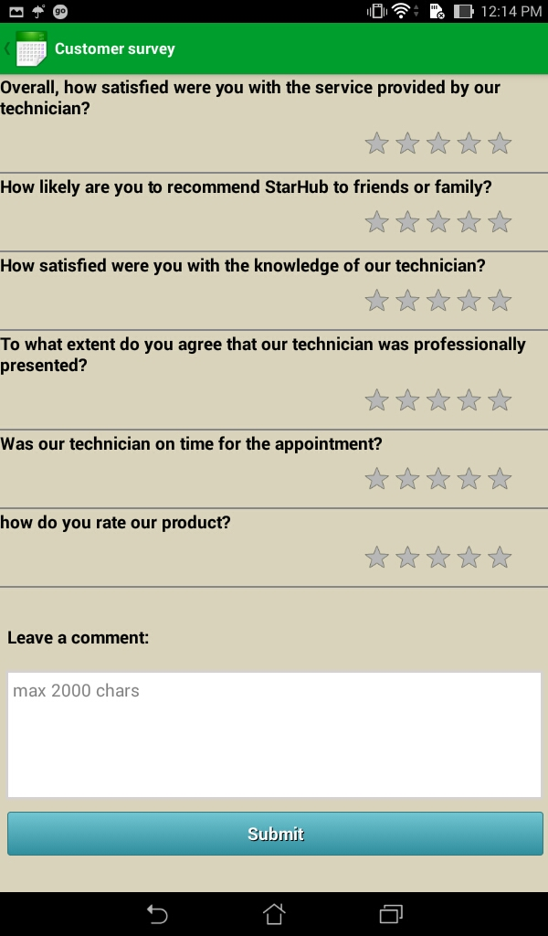

* After taking the customer survey, press the submit button.
* Below pop up will disappear. It mean Customer survey is done

With successful state.

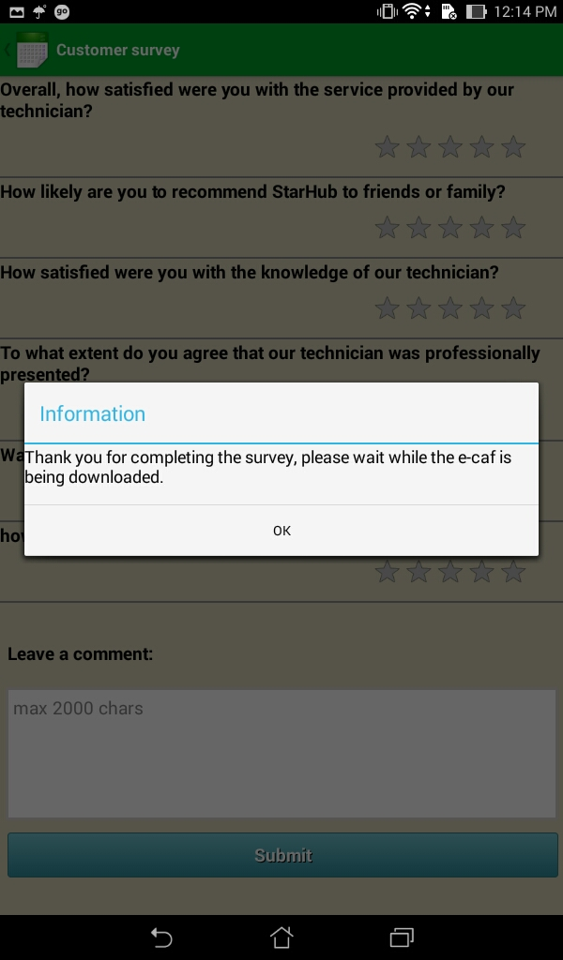

1. **E-CAF process :**

* After completing the customer survey E-CAF will be auto pop up.
* Find the below screens, which are representing E-CAF process.

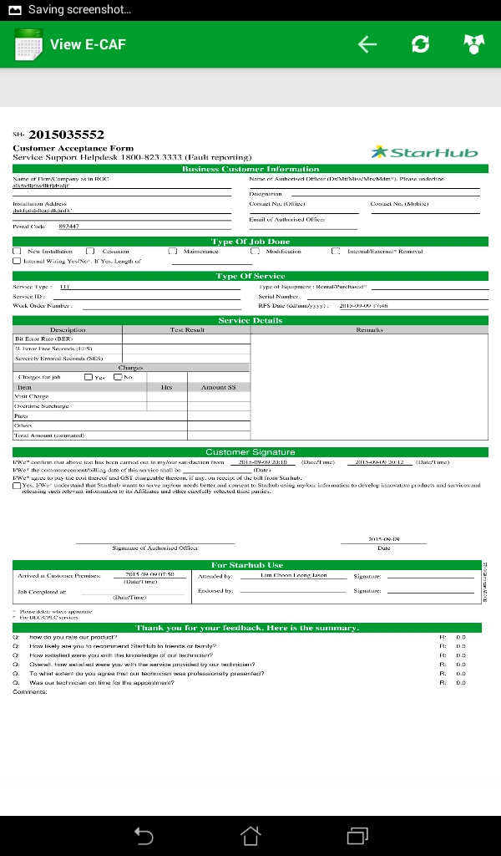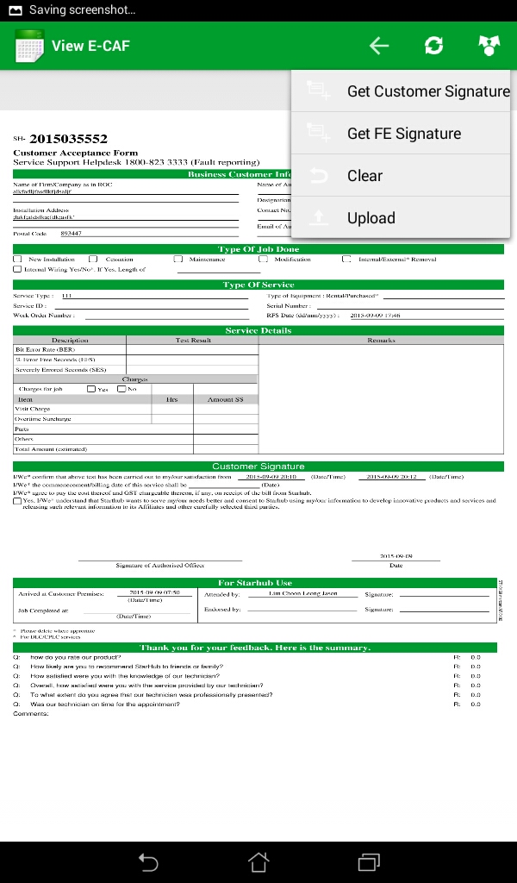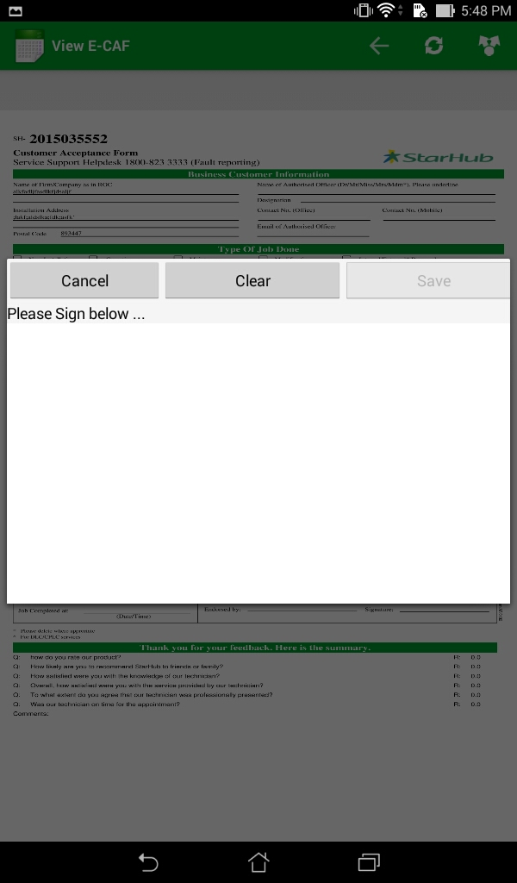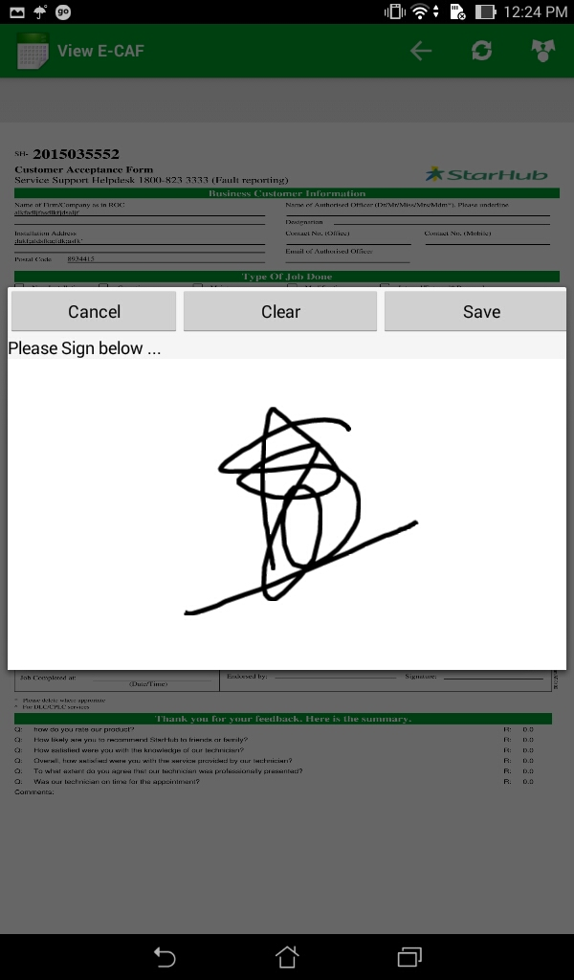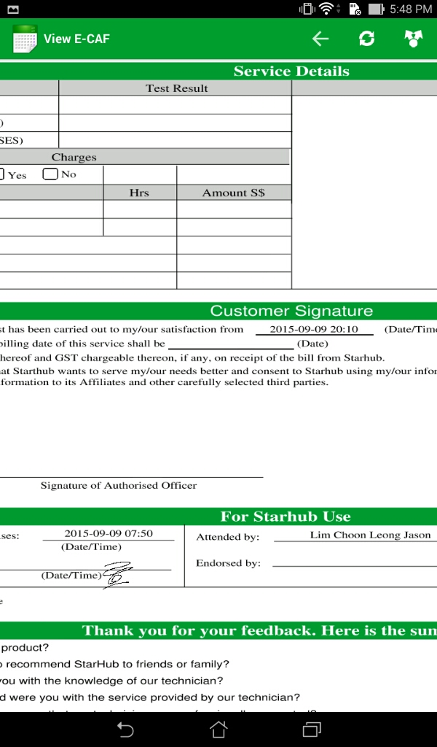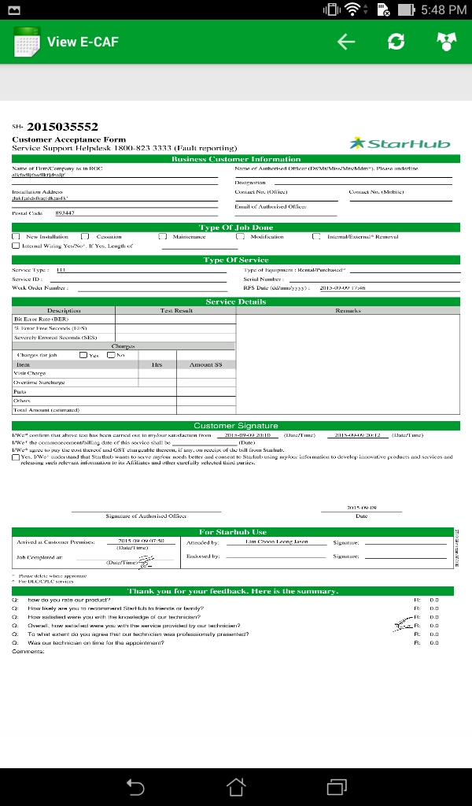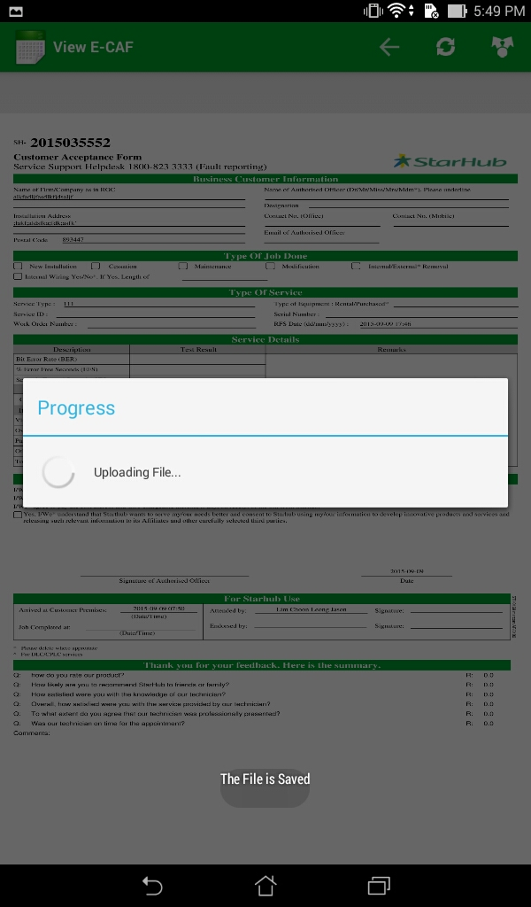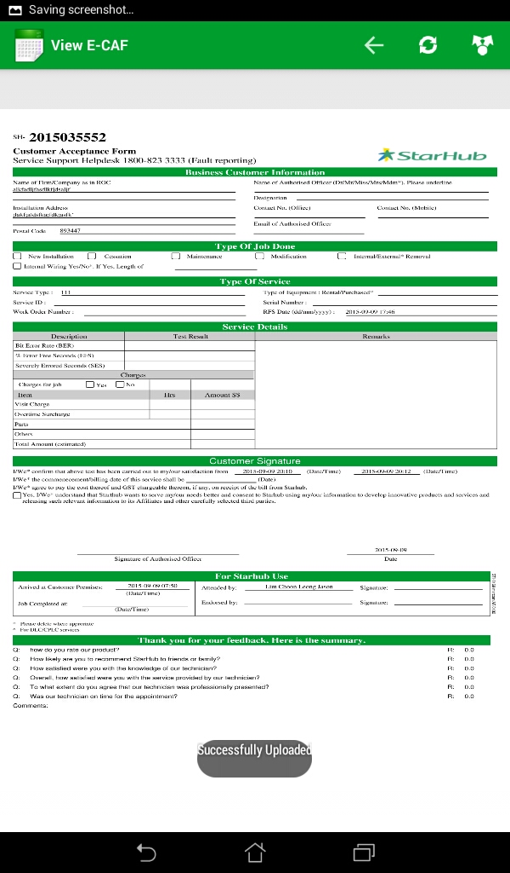

* After E-CAF, press back button the Service activity details

Page will pop up.

